Device Compatibility field is missing when adding a product. It shows up under SEO & Metadata.
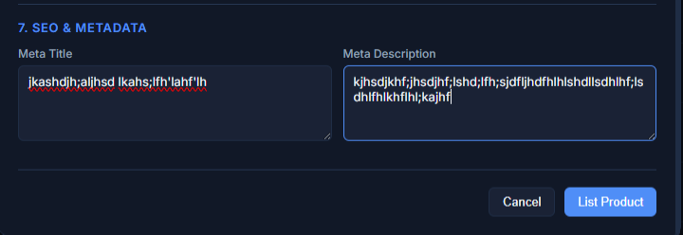

The Product Status and Inventory fields are not being populated based on the data in excel file.
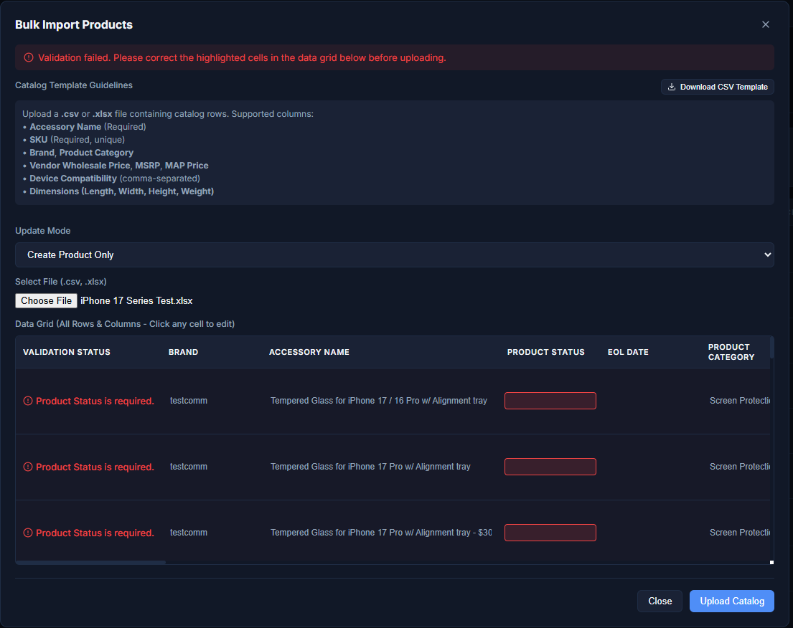
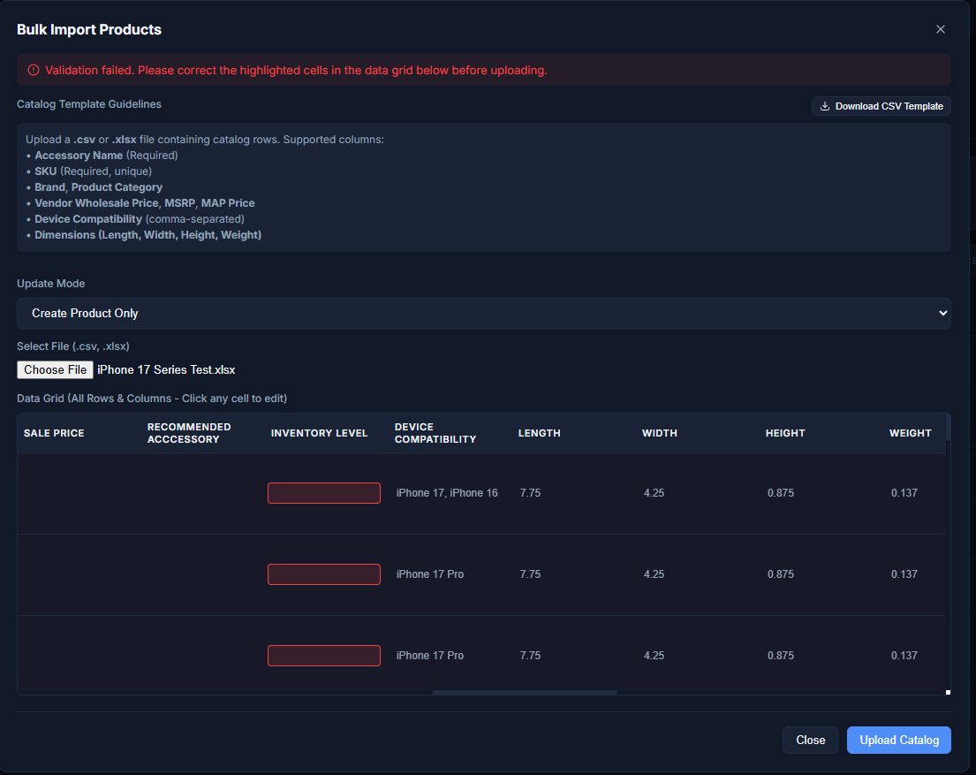
I manually made the updates to the red section and the file successfully loaded.
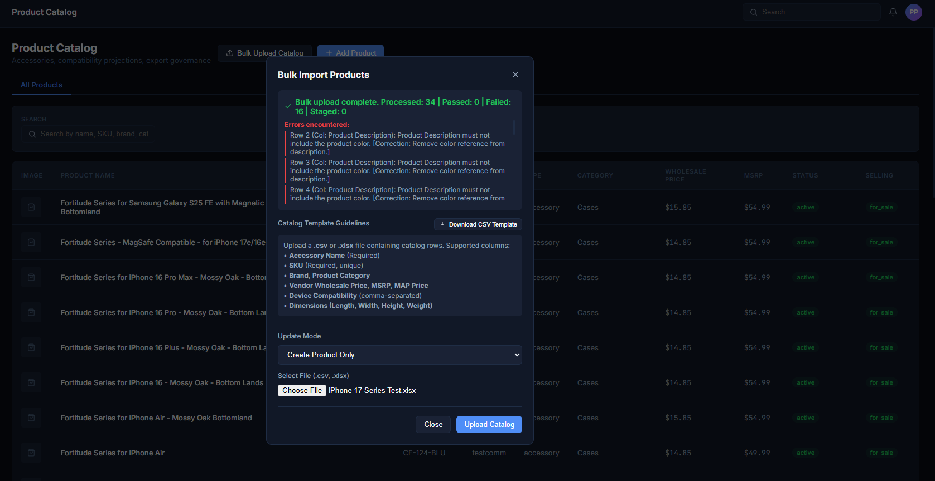
When I click “Close”, I get the error message. But the products have already been imported.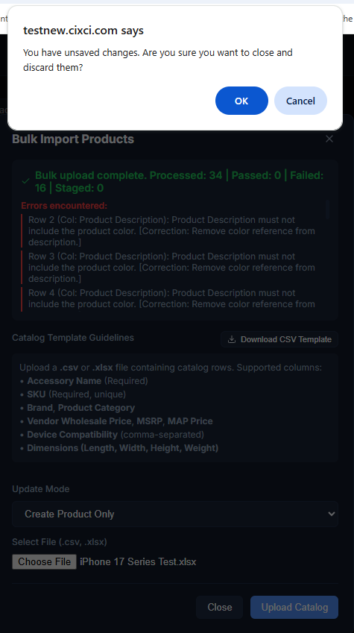
The device compatibility from the Excel file didn’t map to the device compatibility section.
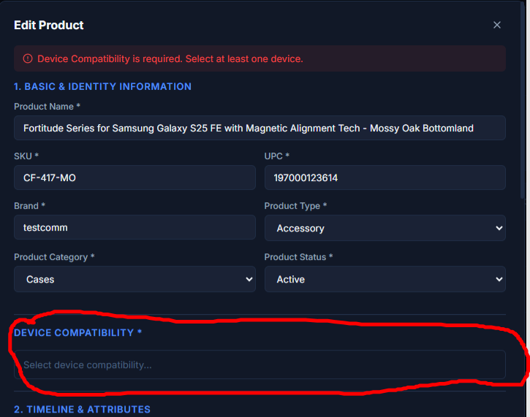

Loaded 5 images to CF-417-MO and only 1 is showing up.
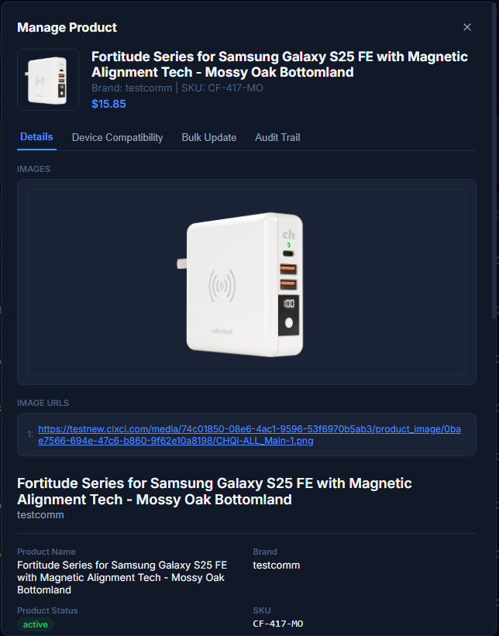
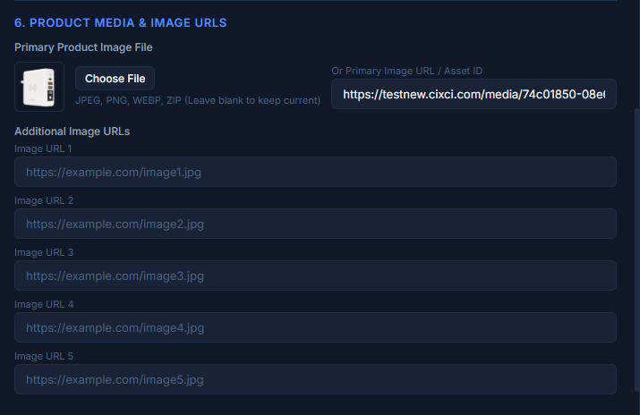
The device compatibility from the excel file isn’t mapping to the product.
https://www.loom.com/share/ad4c0306bef645b9af88da0d38887ec1
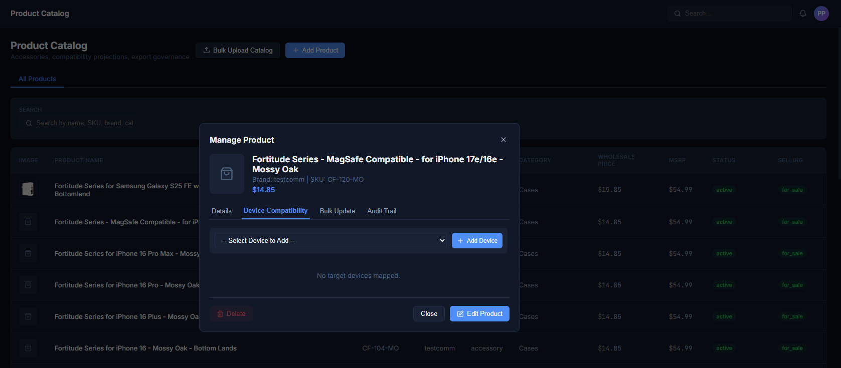
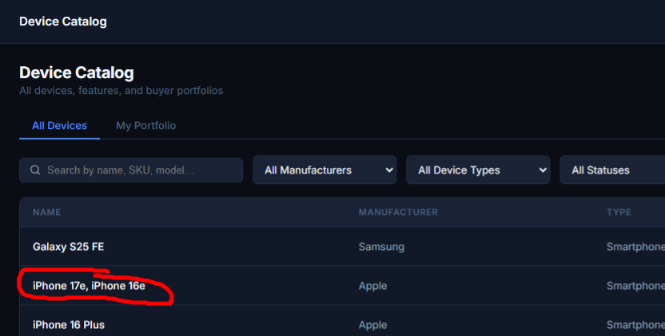

Wrong currency format
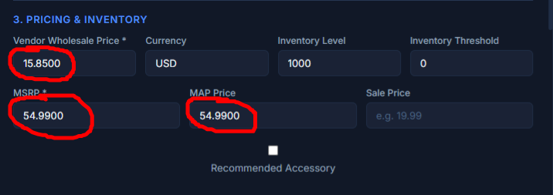

Vendor should be able to search by, Category, Wholesale Price, Color, Status, MSRP, SKU.
Add SKU between Product Name and Brand.
